Southeast University

Tittle: Hospital Management System

Course Title : Programming Language II Lab
Course code: 282.5
Department : CSE
Faculty Name : Mr.Md.Ayon Mia
Work Place : SOUTHEAST UNIVERSITY
Submission Date : 29 september 2026

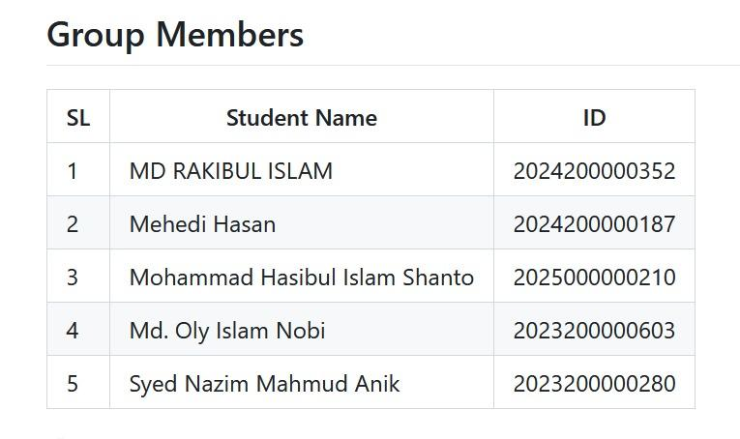

Introduction :

Project Overview
The Hospital Management System (HMS) is a Java-based desktop application designed to assist in managing basic hospital operations, including patient, doctor, nurse, and billing information. The system provides separate functionalities for managing different types of hospital records through a user-friendly graphical interface. It also supports CRUD operations, file-based data storage, billing management, and report generation. The project is developed using Java Swing and demonstrates the practical application of Object-Oriented Programming principles.

Project Objectives
- Provide a platform for managing patient records efficiently.
- Allow users to add, update, view, and delete doctor and nurse information.
- Manage patient billing information and calculate outstanding dues.
- Store and retrieve hospital records using file handling.
- Apply Object-Oriented Programming (OOP) principles in software development.
- Implement exception handling and data validation for reliable system operation.
- Provide a simple graphical user interface for managing hospital activities.

Motivation

Why We Developed This Project
We selected the Hospital Management System project to develop a practical understanding of how Object-Oriented Programming concepts can be applied to a real-world software system. Hospital management involves handling different types of information, such as patient records, doctor details, nurse information, and billing data. Developing this project provided an opportunity to organize these data and operations using Java classes, objects, inheritance, abstraction, encapsulation, and polymorphism.

Real - world Problem
In a hospital environment, managing records manually can make it difficult to maintain, update, and retrieve information efficiently. Patient and staff information may become disorganized, while calculating and tracking patient bills can also require additional effort. Therefore, this project was developed to provide a simple computerized solution for managing basic hospital records.
The system aims to make record management more organized by providing CRUD operations, file-based data storage, billing management, data validation, and report generation through a graphical user interface. It also demonstrates how a software system can be designed to address common data-management requirements in a structured manner.

Applications

Areas of Application
The Hospital Management System can be utilized in small- to medium-sized hospitals, clinics, medical centers, and other healthcare facilities that require a structured mechanism for managing essential administrative records. The system provides a computerized approach to maintaining patient, doctor, nurse, and billing information.

Potential Users
- Hospital Administrators — Responsible for maintaining and supervising patient and staff records.
- Reception and Administrative Personnel — Manage the registration and maintenance of patient-related information.
- Billing Personnel — Record billing transactions and monitor outstanding payments.
- Hospital Management — Review consolidated records and generated reports for administrative purposes.

Practical Uses and Benefits
- Patient Information Management — Facilitates systematic recording, modification, retrieval, and deletion of patient information.
- Medical Staff Management — Maintains structured records of doctors and nurses, including specialization and shift-related information.
- Billing and Due Management — Records patient billing information and automatically determines outstanding payment amounts.
- Data Persistence — Utilizes file-handling mechanisms to preserve and retrieve hospital records.
- Report Generation — Provides summarized hospital information through a dedicated report-generation facility.
- Operational Efficiency — Reduces repetitive manual record-keeping activities and improves the organization of administrative information.
- Centralized Graphical Interface — Provides an integrated Java Swing interface for accessing and managing the major functional modules of the system.

Project Description
The Hospital Management System (HMS) is a Java-based desktop application developed to facilitate the systematic management of essential hospital information. The system provides an integrated graphical interface through which authorized users can manage patient, doctor, nurse, and billing records.
The application follows an object-oriented architecture in which common attributes and behaviors are organized through a hierarchical class structure. The Person class serves as the abstract base class, while Patient, Doctor, and Nurse extend it to represent different categories of individuals within the hospital environment. The SimpleHospitalApp class manages the graphical user interface and coordinates the major operations of the system.
The system also incorporates file handling for persistent data storage, exception handling for invalid input, and report generation for summarizing stored information.

Features and Functionalities
The major features of the system include:
- Patient Management — Addition, retrieval, modification, and deletion of patient records.
- Doctor Management — Management of doctor information, including specialization details.
- Nurse Management — Management of nurse information, including assigned shift details.
- Billing Management — Recording of total bills and paid amounts and calculation of outstanding dues.
- File-Based Data Storage — Persistent storage and retrieval of patient, doctor, and nurse records using text files.
- Data Validation — Validation of input data through custom exception handling and built-in exceptions.
- Report Generation — Generation of a hospital report containing relevant patient, doctor, nurse, and billing information.
- Graphical User Interface — An interactive interface developed using Java Swing for accessing the different modules.

Modules and Classes for system
Module/Class | Description
Person | Abstract base class containing common attributes and behaviors for hospital personnel and patients.
Patient | Represents patient information, including age, disease, and billing details.
Doctor | Represents doctor information and specialization.
Nurse | Represents nurse information and assigned shift.
SimpleHospitalApp | Controls the graphical interface, CRUD operations, file handling, billing, and report generation.
InvalidDataException | Custom exception class used for handling invalid data.
Main | Serves as the entry point for launching the application.

Work Flow of System

Application Start
↓
Login
↓
Dashboard
↓
┌─────┼─────────┬──────────┐
↓ ↓ ↓ ↓
Patient Doctor Nurse Billing
Management Management & Report
↓ ↓ ↓ ↓
CRUD CRUD CRUD Bill/Due
↓ ↓ ↓ ↓
File-Based Storage
↓
Report Generation

What Java and OOP Concepts we Used :
The project applies several fundamental Java and Object-Oriented Programming concepts:
Encapsulation:
Data members are declared as private within the relevant classes, while controlled access is provided through public methods such as getters.
Inheritance:
The Patient, Doctor, and Nurse classes inherit common properties and behaviors from the Person class, reducing code duplication and establishing a hierarchical relationship.
Abstraction:
The Person class is declared as an abstract class and defines the abstract getRoleInfo() method. This provides a common structure while allowing subclasses to provide their own implementations.
Polymorphism:
The overridden getRoleInfo() methods of Patient, Doctor, and Nurse can be accessed through Person references, allowing different subclass objects to be handled through a common parent type.
Exception Handling:
The project uses the custom InvalidDataException class together with built-in exception handling mechanisms to validate input and manage potential runtime errors.
File Handling:
Java file I/O mechanisms are used to save and retrieve hospital records from text files, providing basic persistent data storage.
Collections:
ArrayList is used to maintain collections of patients, doctors, and nurses dynamically during program execution.

Tools & Technologies

Programming Language and Version
The project is developed using Java as the primary programming language. Java was selected because of its strong support for Object-Oriented Programming, platform independence, exception handling, file I/O, and graphical user interface development.
- Programming Language: Java
- Java Version: Java 17 or later
- Programming Paradigm: Object-Oriented Programming (OOP)

IDE Used for Development
The project was developed and tested using IntelliJ IDEA, which provides an integrated environment for Java application development.
- IDE: IntelliJ IDEA
- Build/Execution: Java compiler and IntelliJ IDEA's built-in execution environment
- Version Control: Git
- Repository: GitHub
Libraries and Frameworks Used
The project primarily uses Java Standard Library APIs rather than external frameworks.
Library / API | Purpose
Java Swing (javax.swing) | Development of the graphical user interface, including frames, panels, buttons, tables, dialogs, and input fields.
AWT (java.awt) | GUI layout, components, fonts, colors, and event-related functionality.
Java I/O (java.io) | Reading from and writing data to text files for persistent storage.
Java Collections (java.util.ArrayList) | Dynamic storage and management of patient, doctor, and nurse objects.
Java Utility Classes (java.util) | Supporting data processing and general application operations.

Output :

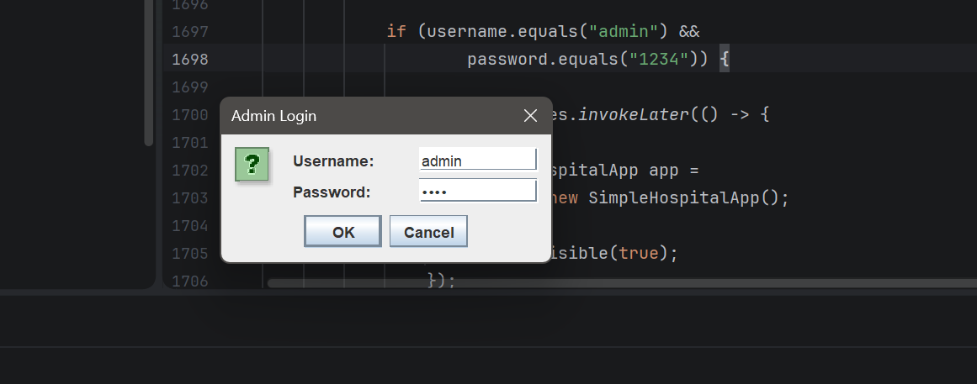
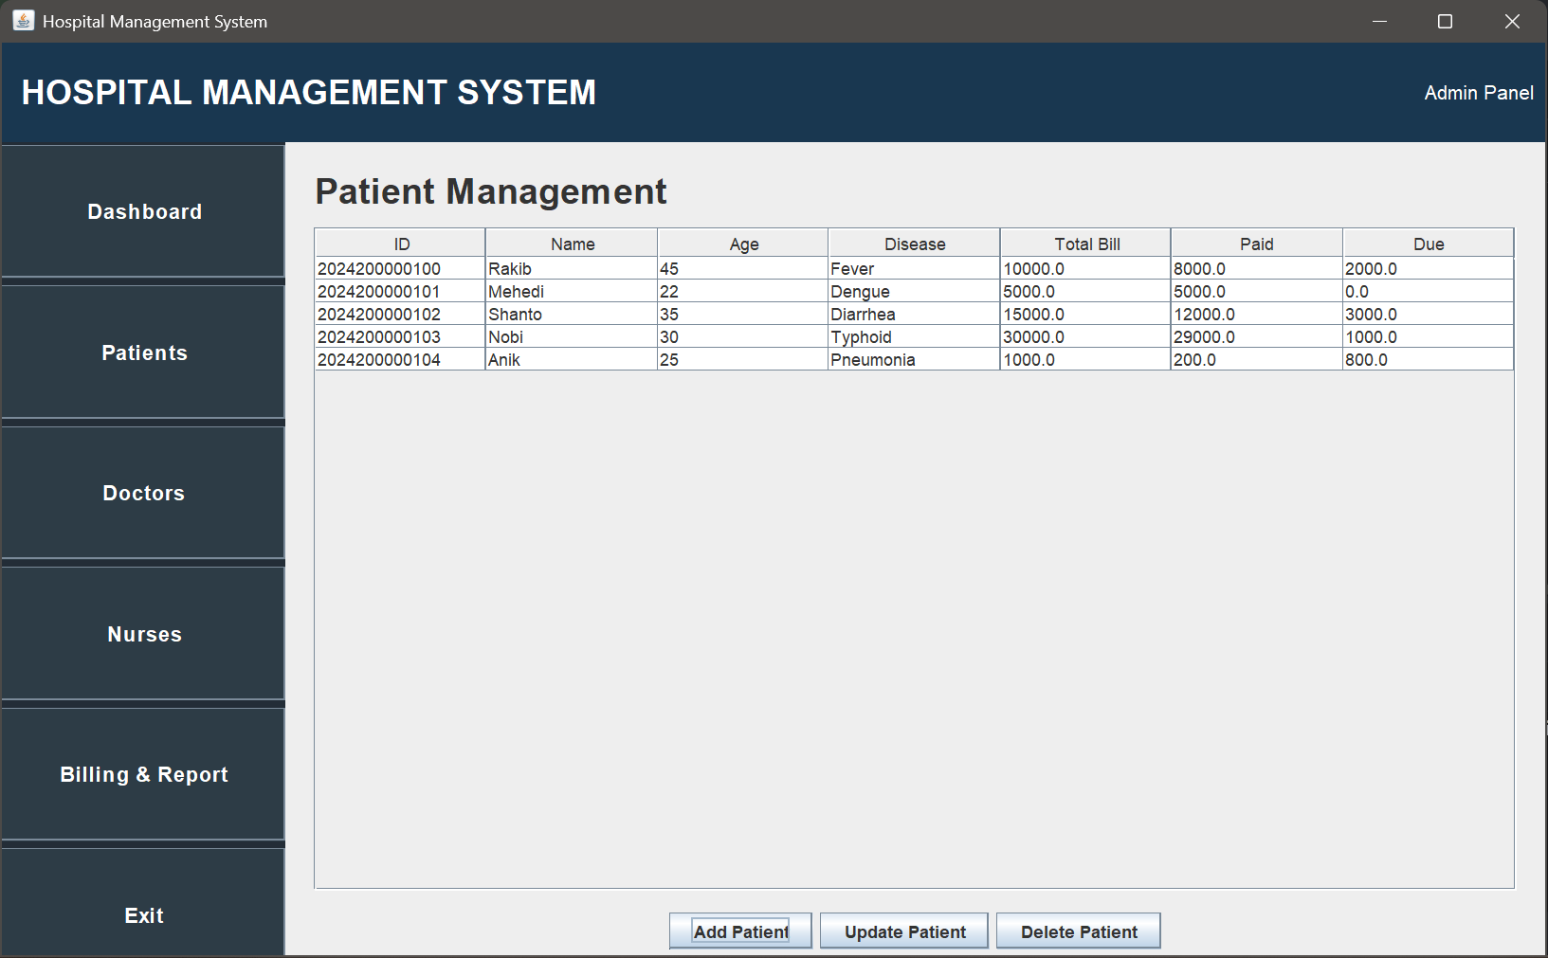

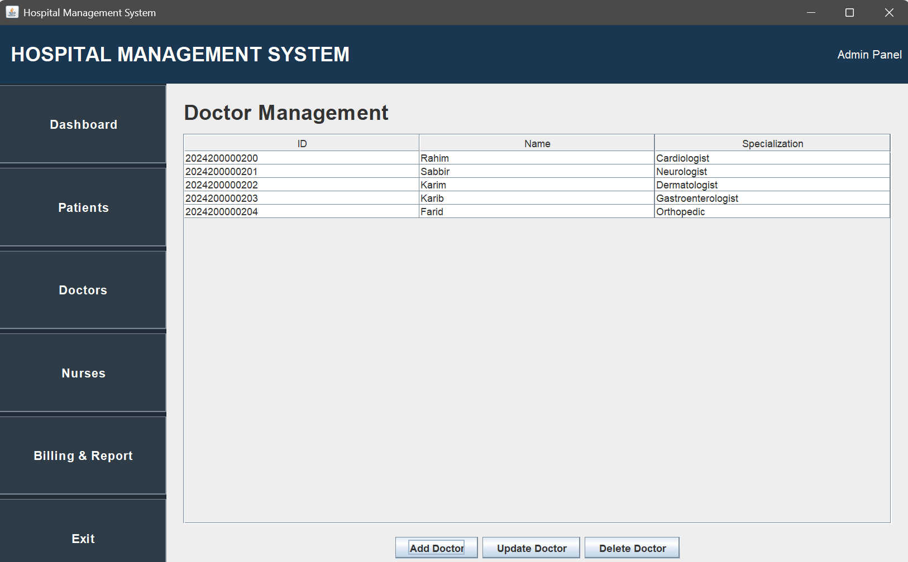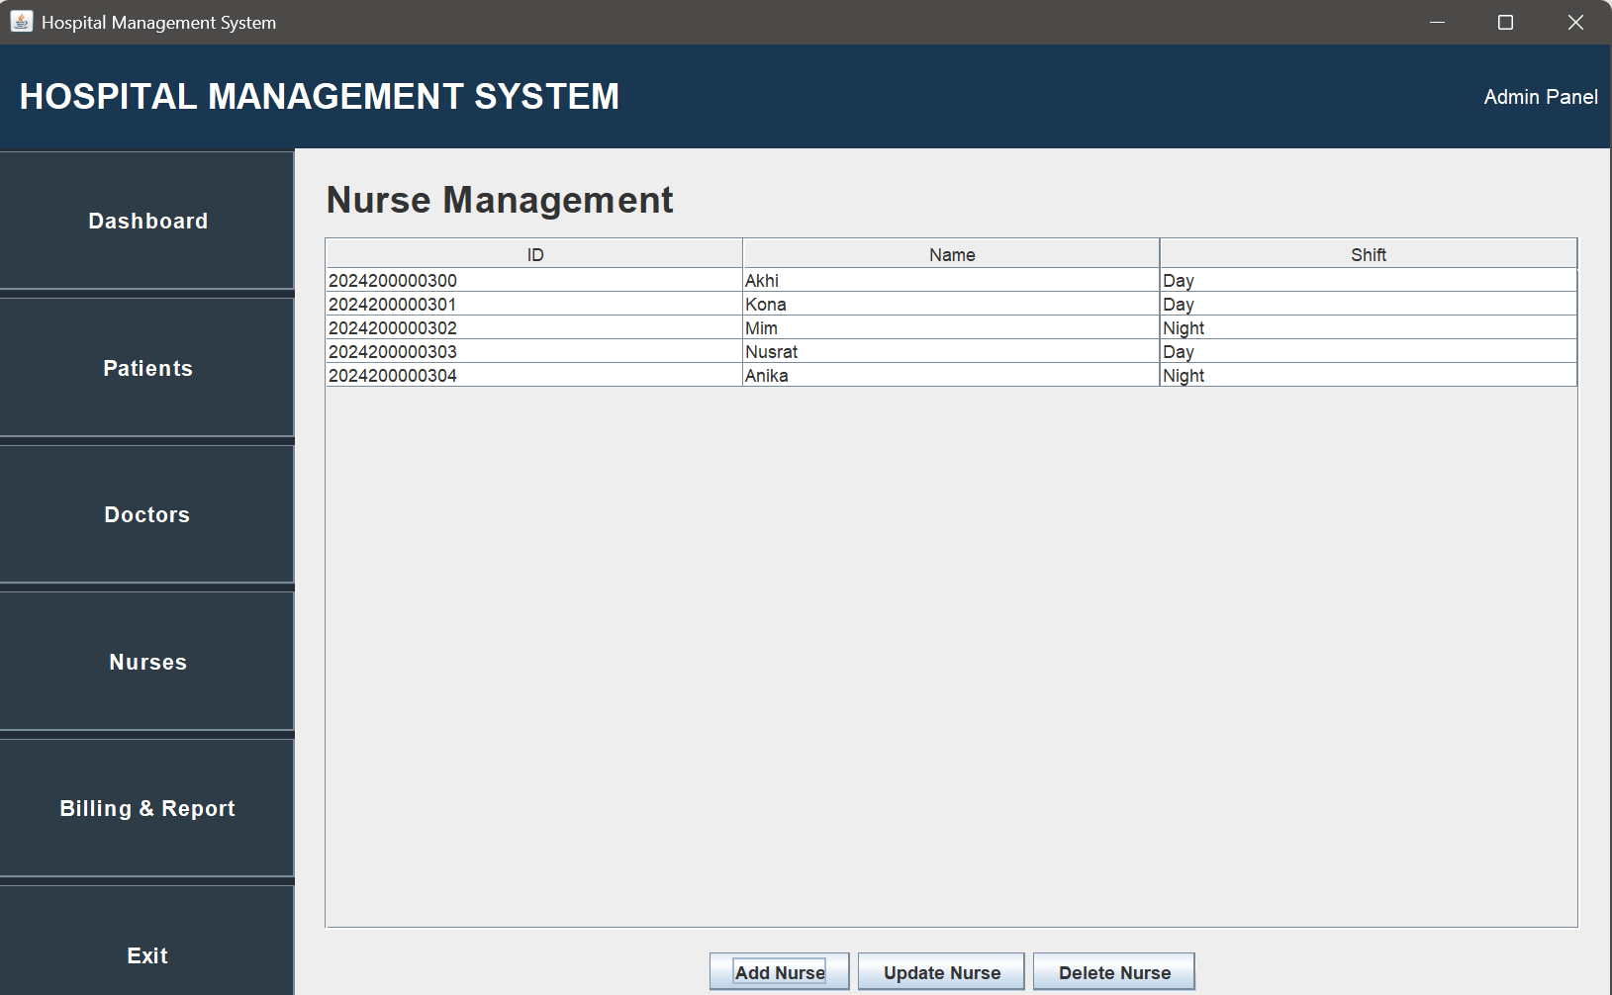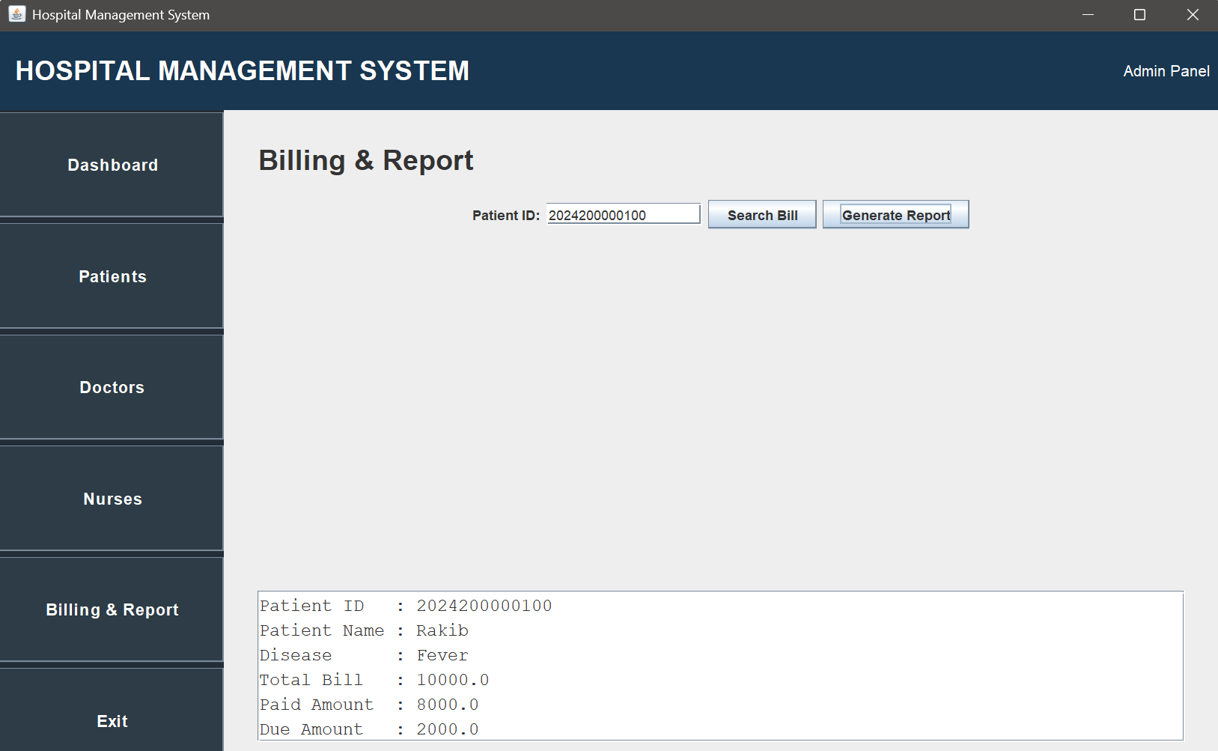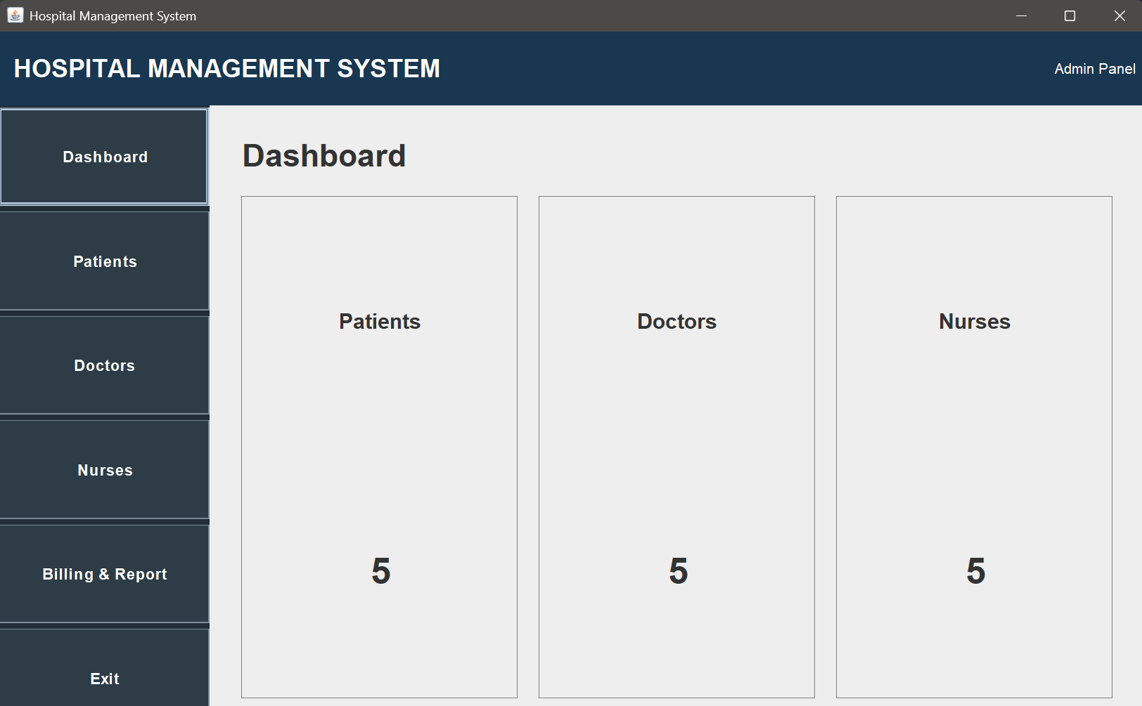

Project Diagram :
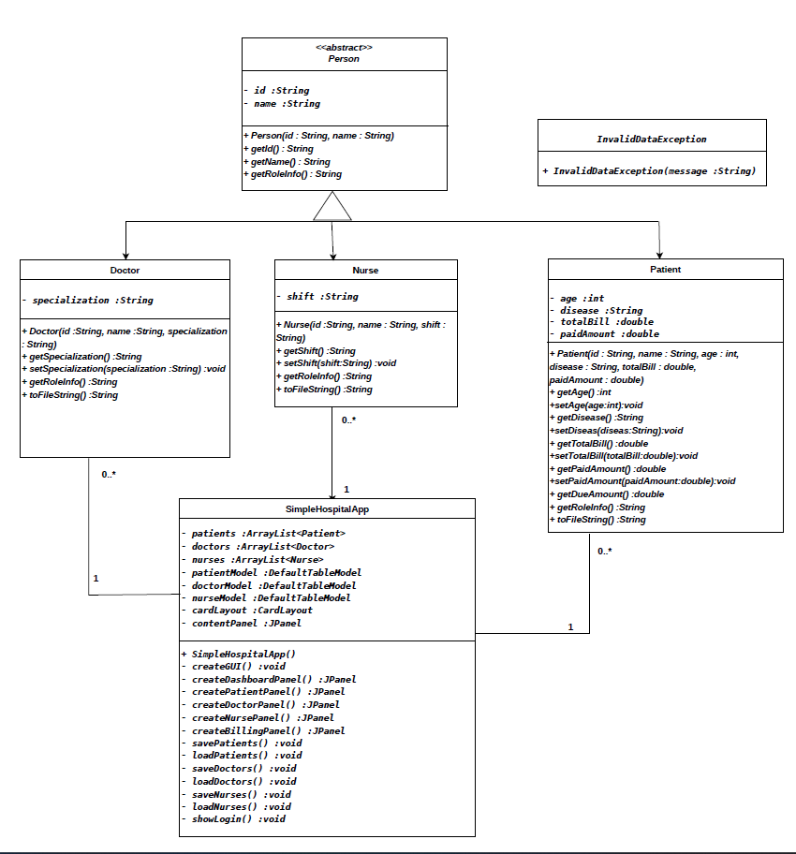

Conclusion

Summary
The Hospital Management System has been successfully implemented as a Java-based desktop application for the systematic management of patient, doctor, nurse, and billing records. The system integrates Java Swing, file handling, CRUD operations, exception handling, and core OOP principles.

Achievement of Objectives
The defined objectives have been successfully fulfilled. The system provides essential record-management, billing, data-persistence, and reporting functionalities while demonstrating the practical application of OOP concepts.

Limitations
- Utilizes text-file storage instead of a database.
- Provides basic authentication and access control.
- Limited to a desktop-based environment.
- Does not include advanced hospital functions such as appointment, prescription, and bed management.

Future Improvements
- Integration with a relational database such as MySQL.
- Implementation of role-based access control.
- Addition of appointment, prescription, and bed-management modules.
- Enhanced reporting with PDF export.
- Development of a web-based or mobile platform.

